Ideation Phase Empathize & Discover

|  |  |
| --- | --- |
| Date | 19 September 2022 |
| Team ID | PNT2022TMID03711 |
| Project Name | Smart solution for Railways |
| Maximum Marks | 4 Marks |

**Empathy Map Canvas:**

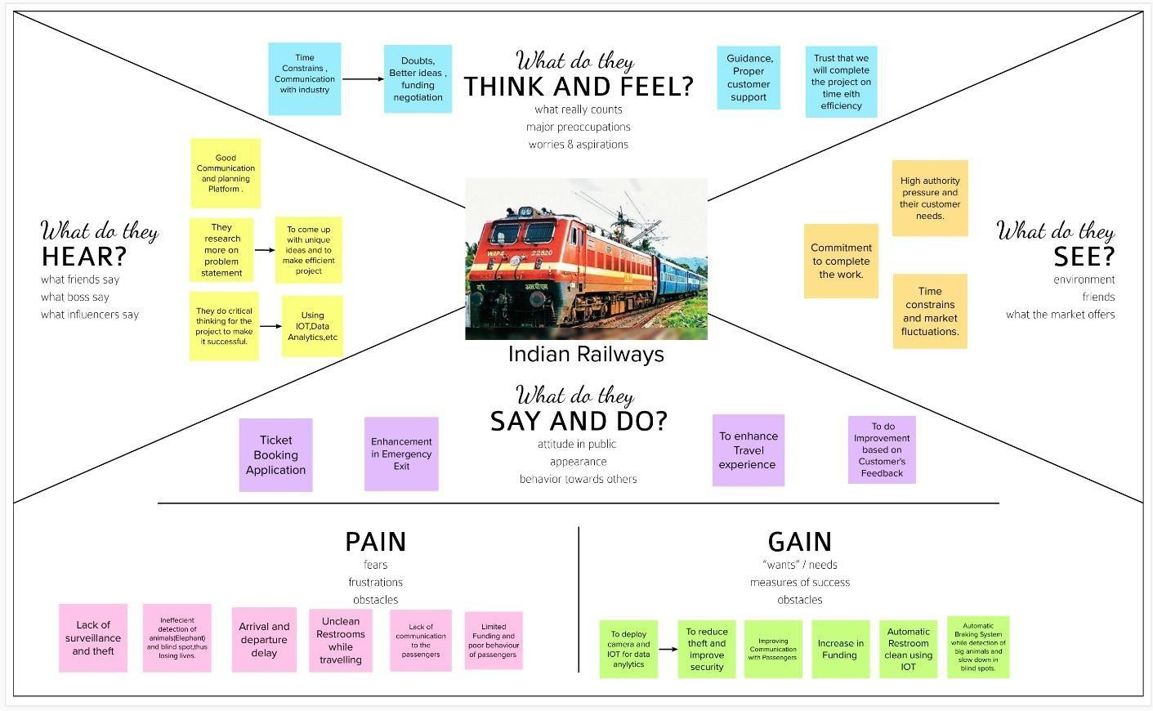An empathy map is a simple, easy-to-digest visual that captures knowledge about a user’s behaviors and attitudes.